

**Multi-Approval Module**

Multi-Approval Module

Table of Contents

**Basic Knowledge3**

**Modules4**

Assigning Authenticators4

Example: Creating ILC Rule5

Example: Creating ILC9

Example: Approving the ILC11

1. **Basic Knowledge**

The **Multi-Approval** Module is created to allow authenticators to control the creation or modification of ELCs (Exported Letter of Credit), ILCs (Imported Letter of Credit), Accounts & Beneficiaries:

* ELC, ILC & Beneficiaries will be added, edited or deleted only when approved by their authenticators (Approvers).
* Previously created accounts will only be edited or deleted after their authenticator’s approval. However, if a new account will be created where a restriction is needed, the rule should be applied for all accounts.

Note: A letter of credit is a letter from a bank to guarantee that a payment will be received on time and with the correct amount.

1. **Modules:**

**Step 1: Assigning Authenticators**

Before starting with the creation of a Module Rule, the first thing to do is to assign which users to be the authenticators (Signers/ Approvers).

* Go to SecuritySetting/UserSecurity/UserManagement Page
* Select the wanted user to be the Authenticators and press on **Roles** Button

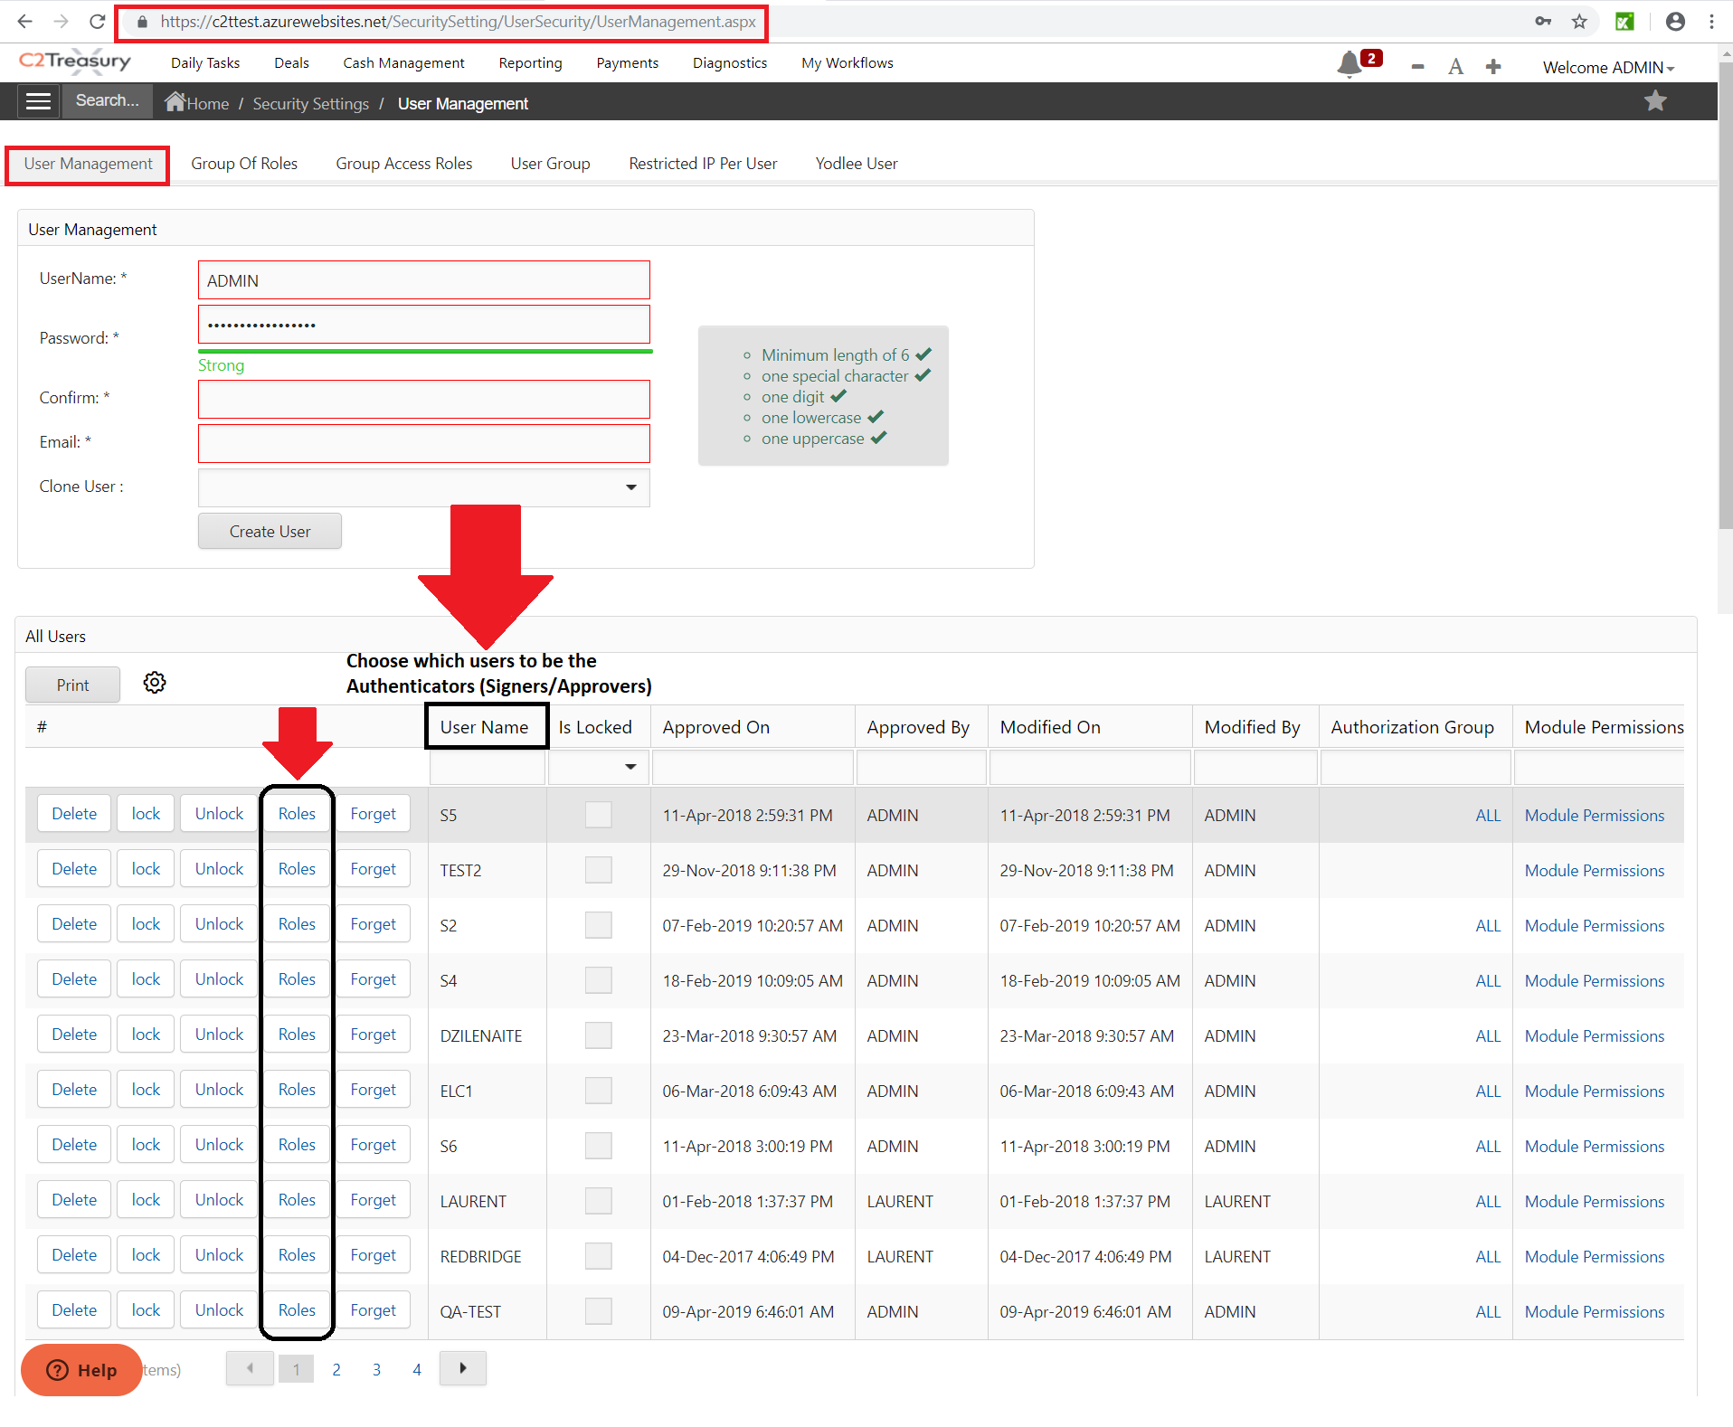

* After pressing on **Roles** button, the Authenticator check box should be enabled.

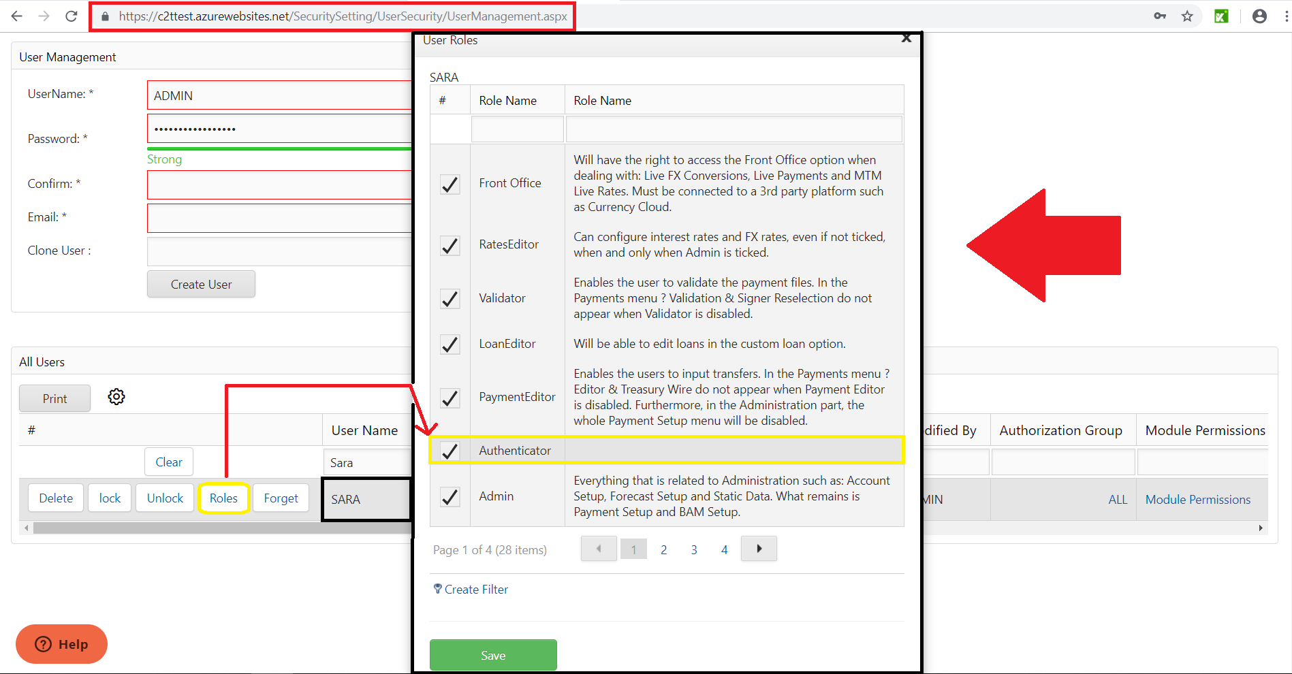

**Step 2: Example: Creating an ILC Rule**

* Go to SecuritySetting/UserSecurity/MultiApprovalSetting page to fill the information of the ILC Rule required
* **Module**: Select the ILC/Guarantee since we’re doing an ILC Rule

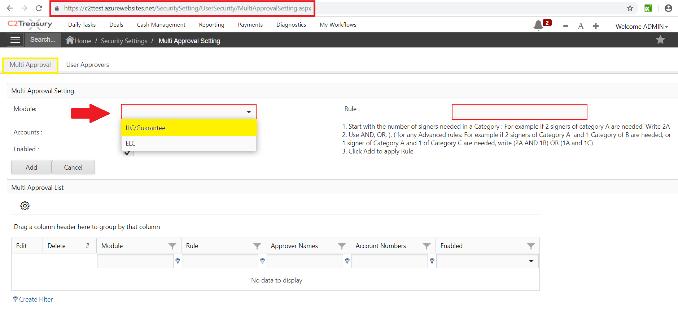

* **Accounts**: The rule could be either assigned for all the accounts, meaning all the accounts require approvers (Leave the field empty), or assigned for specific account(s), meaning only these accounts selected will need the authenticator’s approvals (Click on the Dropdown List to select the account(s)).

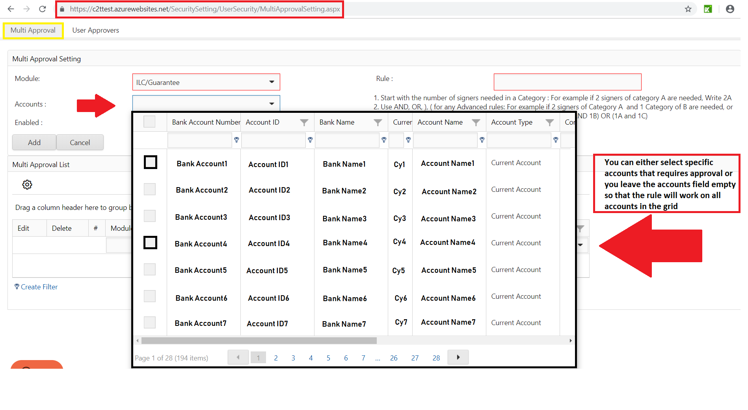

* **Enabled**: This button will either enable this rule or disable it. If this button is not being Checked, the rule created will not be effective. Otherwise, it will work on the specified accounts.

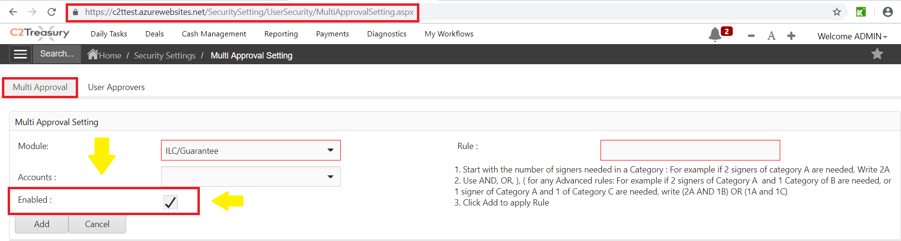

* **Rule**: The number of Approvers will be specified in this field. Each rule can differ from one another. The format of the rule must be as mentioned in the figure below.

There are 3 type of rules:

* + AND Rule: if you put 1A AND 2B for example, the ILC will need the approval of these 3 approvers to be saved in the system
  + OR Rule: The ILC will need the approval of one of the authenticators to be saved in the system (For ex: 1A OR 1B)
  + Combined Rule: The ILC will need the approval of the assigned number of approvers (For ex: 2A).

Note: A signer can approve or reject the ILC. However, in the rejection case, whatever the rule was, if one of the authenticators rejects the ILC, the ILC will not be saved automatically.

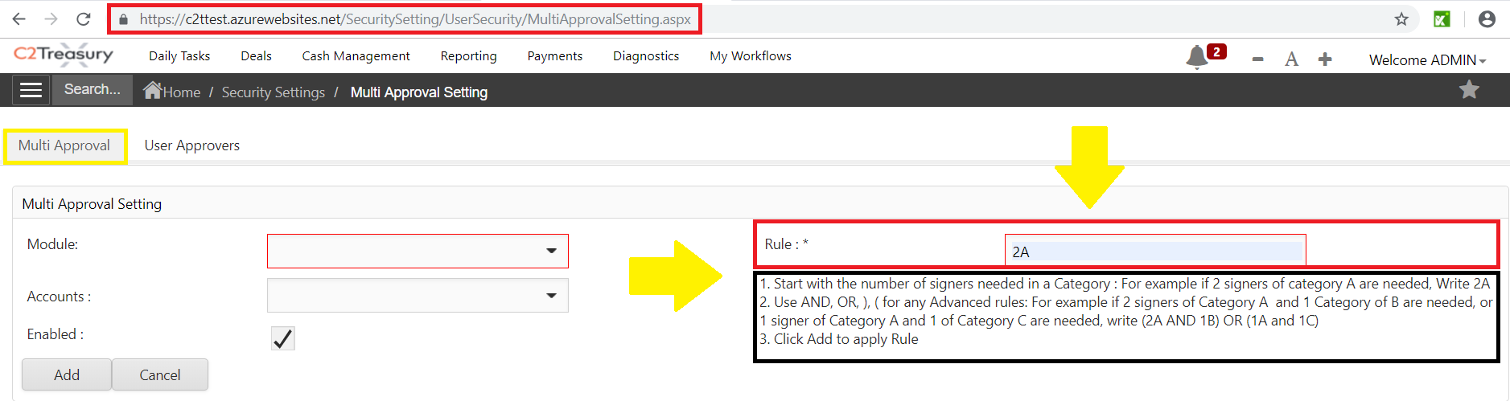

Kindly check the below screenshot to see an example:



* After adding the rule, press on **Approvers** to assign the specified authenticators for this rule.

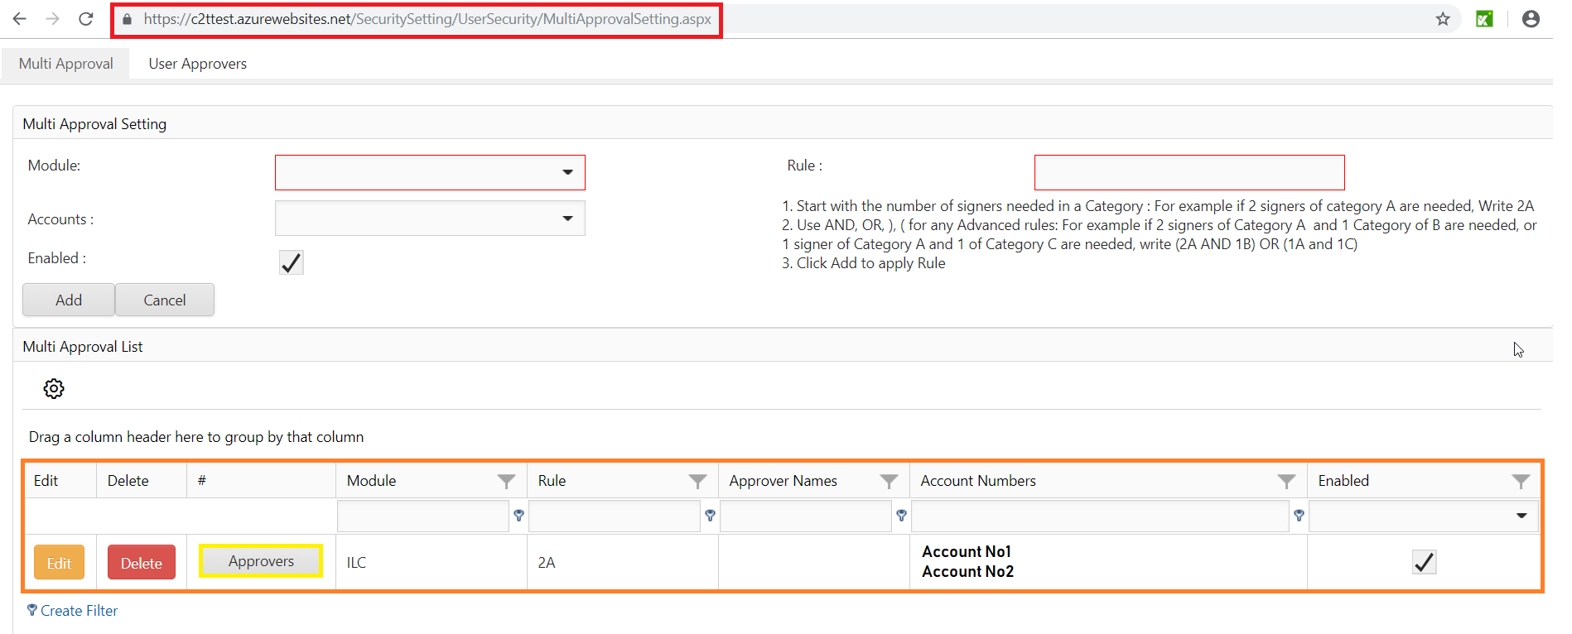

* When pressing on **Approvers**, a new page will open where you have to specify the approvers for the rule you created. In our example, we selected 2A 🡪 So 2 approvers in the same Category are needed for this ILC Rule.

After adding the first approver, just go to the Module list and press the last item for the second approver.

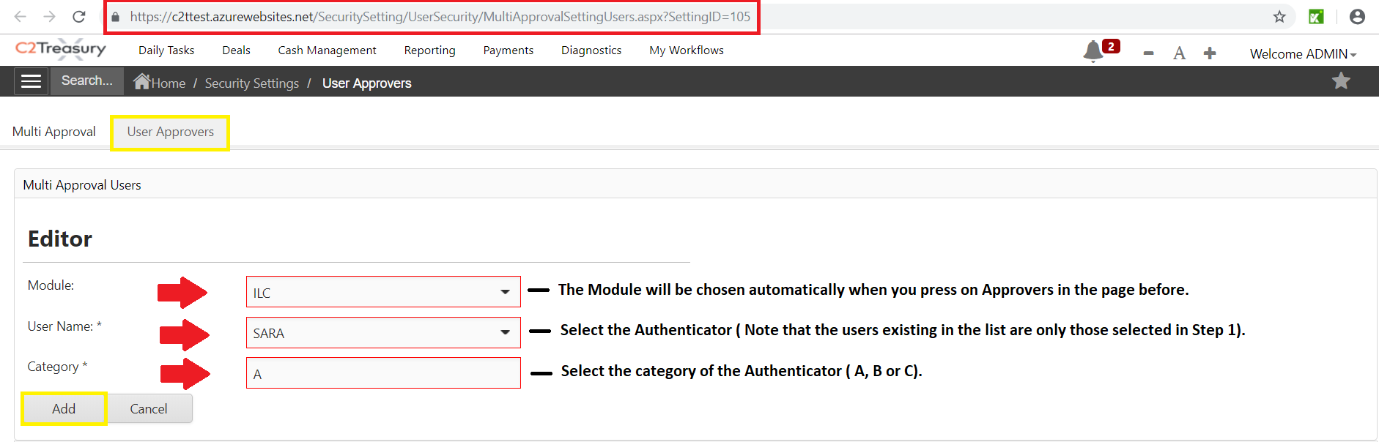

* After adding the approvers, Approvers will be automatically generated in the Multi-Approval grid.

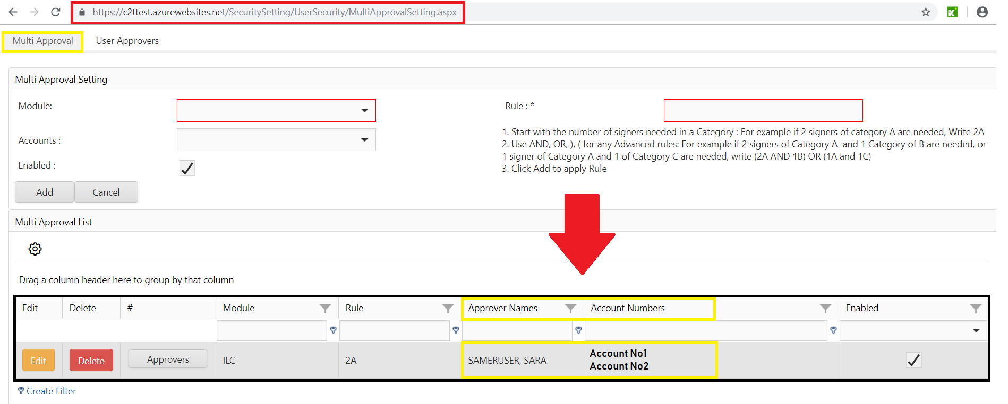

**Step 3: Example: Creating ILC**

After creating the ILC Rule, an ILC should be created.

* Go to FinancialOperations/ILC Page to create an ILC
* Fill the information of the desired ILC

Note: If the rule was made for specific accounts, only the specified accounts will be affected by this rule. Otherwise, if you select an account that is not specified in the rule, it will not be affected.

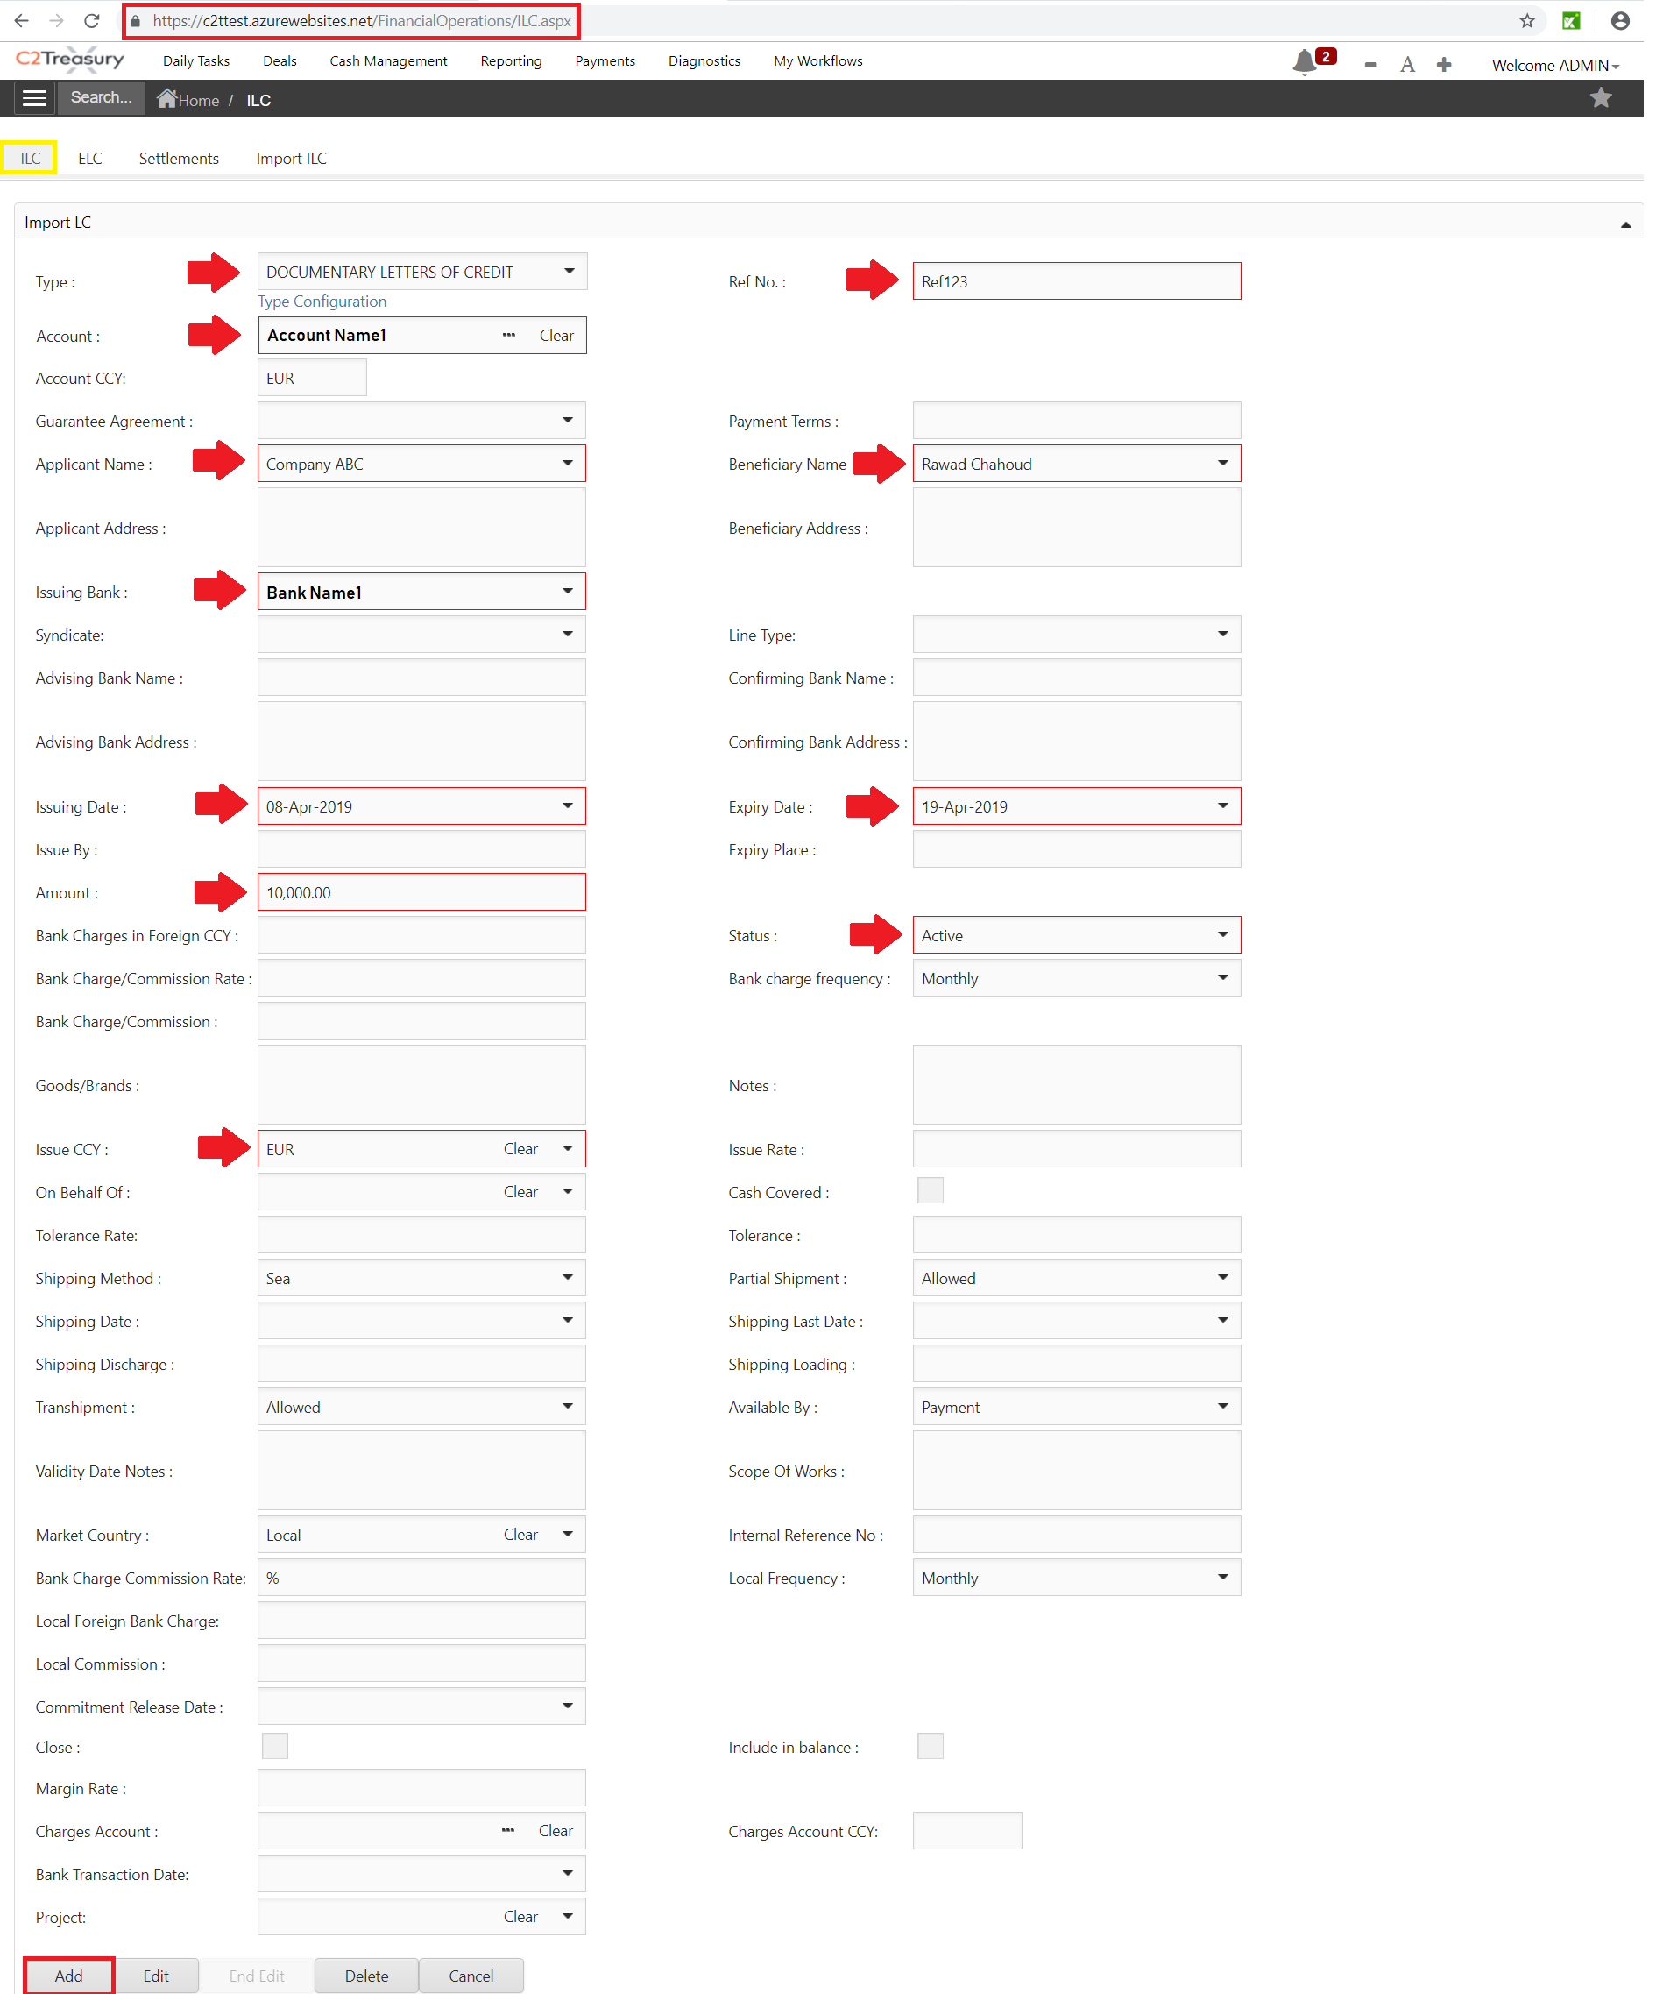

Note: After selecting the account, some fields will be generated automatically: Issuing Bank & Issue CCY.

* After adding the rule, a pop-up will appear where you can write some notes/ details to the Approver.

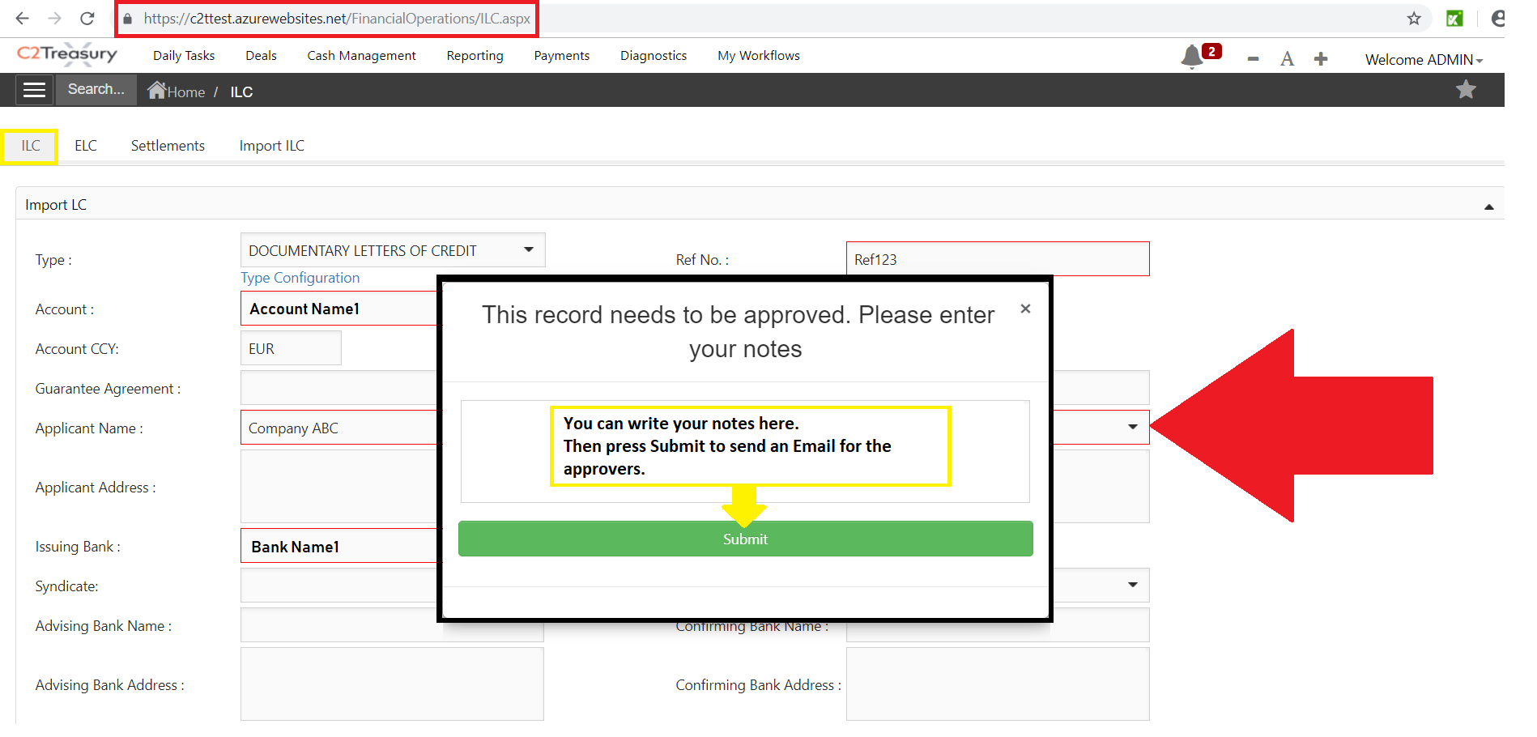

**Step 4: Example: Approving the ILC**

* After Submitting the message, an Email will be sent to the Authenticators to be notified.

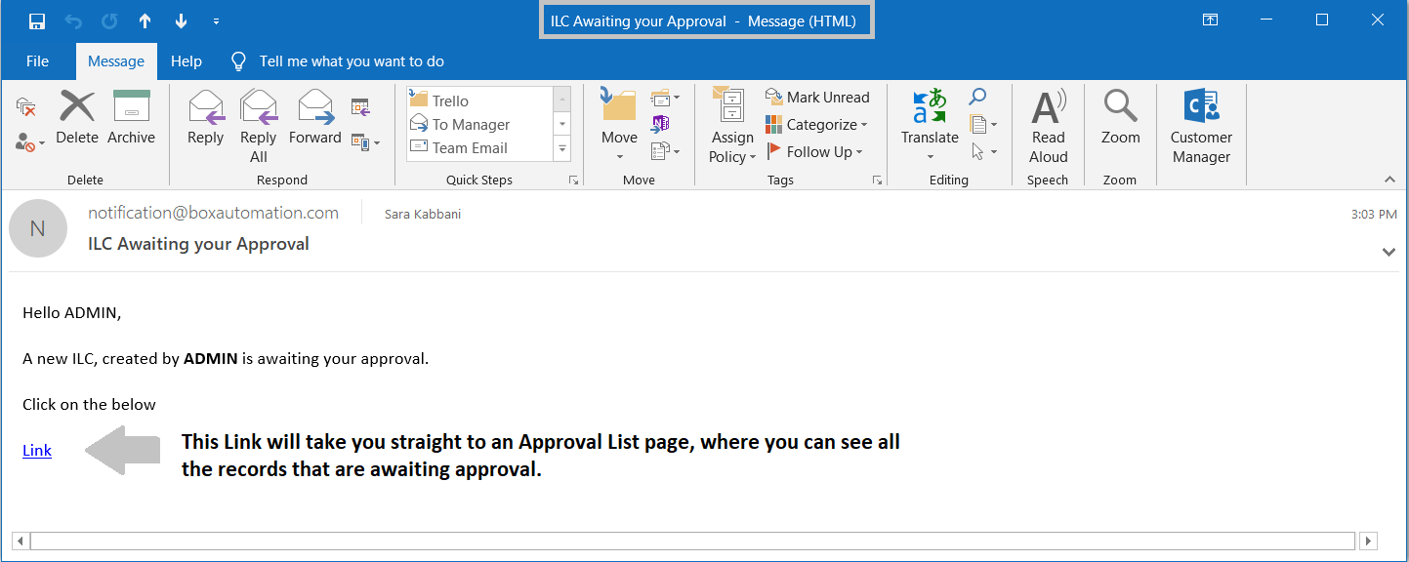

* Let the authenticator log in into the system with his own Credentials
* Once logged in, a pop-up will appear showing all the information of the record that is awaiting an approval. The authenticator will then approve or reject the record.

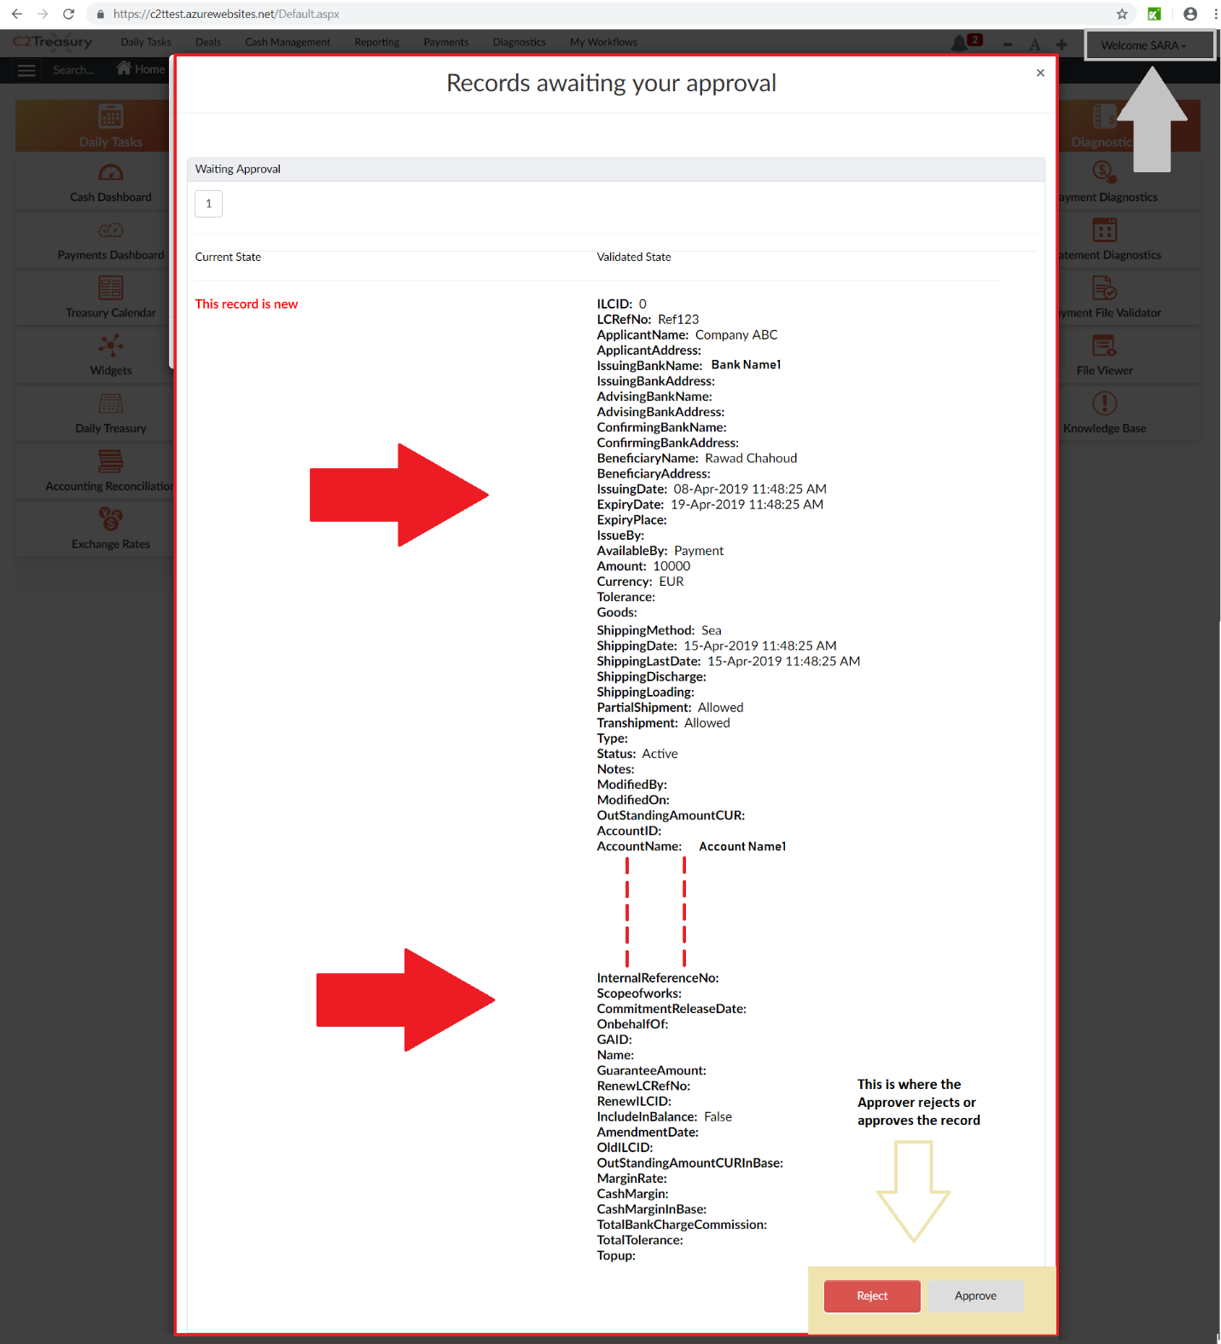

* Once the record is approved by both authenticators, the ILC will be saved automatically in the ILC Module Grid in the bottom of the page.

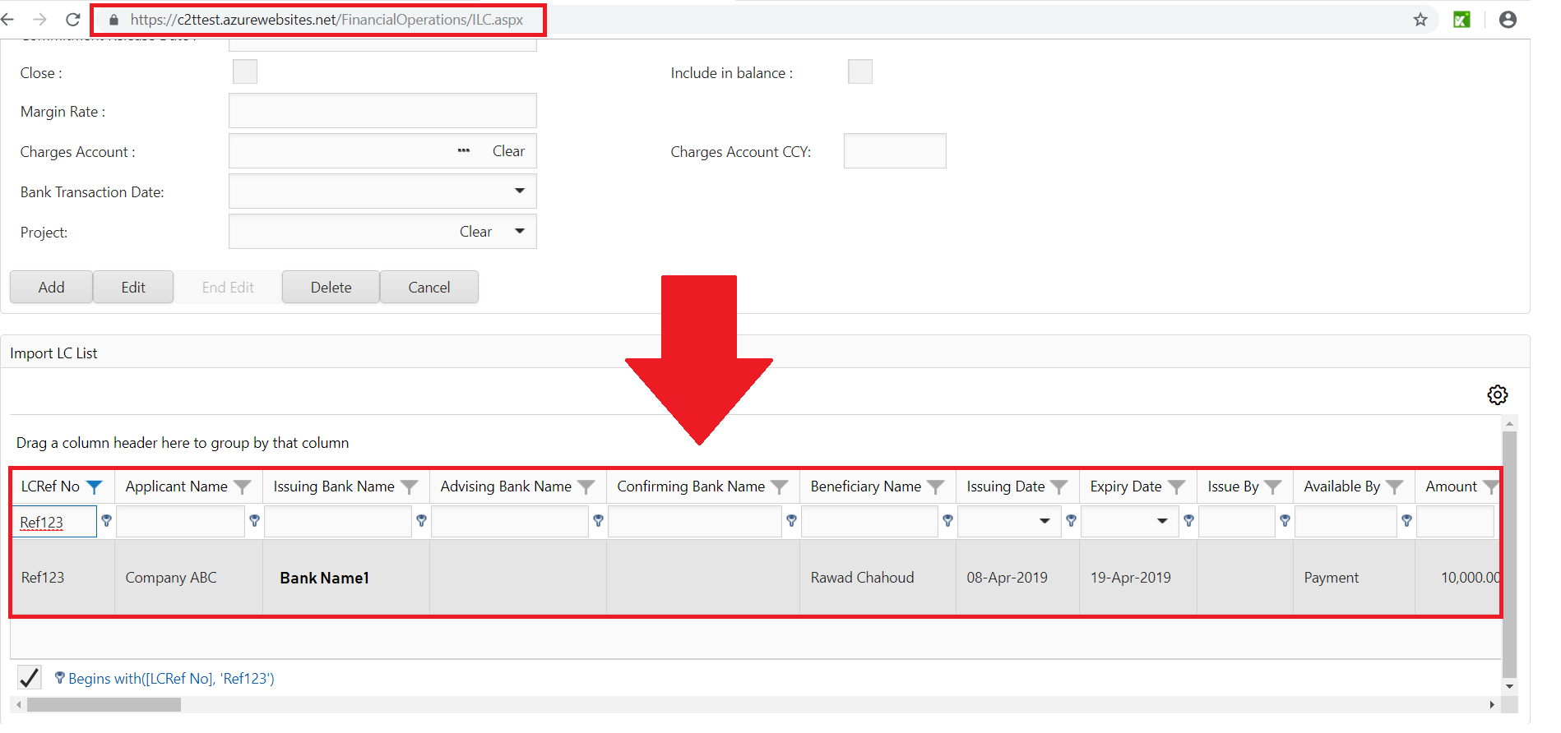

Note: The pending records that are waiting for approvals can be previewed in the **Approval List** page.

* Go to Review/ApprovalList Page to check the pending records.

